

Battlab-One

Quick Start Manual

Thank you for purchasing the Battlab-One! This guide should help you find the necessary software and support for your new Battlab-One.

The executable application software can be found on my Github site here:

<https://github.com/petersdw1/BattLab-One>

1. 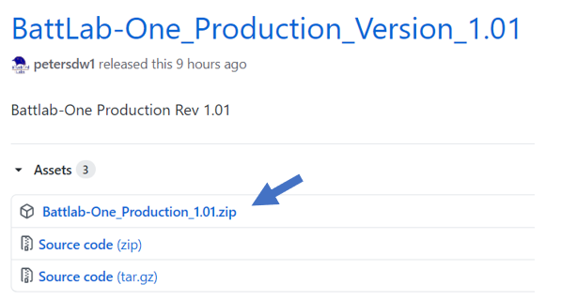Look for the Latest Release and click on the Zip file:

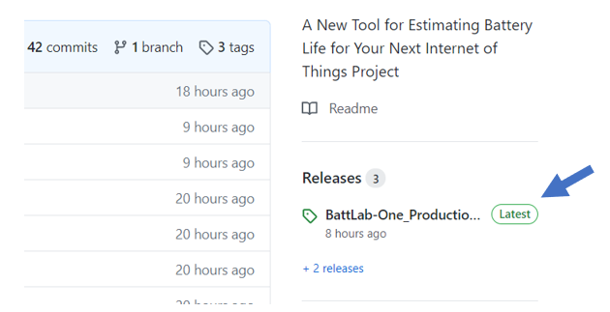

1. Once you’ve downloaded the Zip file, un-compress it to the location you choose. The Battlab-One application is the .exe file. The un-compressed folder should look like this:

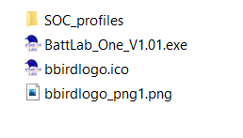

**NOTE:** The SOC_profiles folder **must** be present and contain the State of Charge (SOC) .csv files for the batteries you intend to use. Bluebird Labs will be updating these from time to time so please check the website for newer profiles at <www.bluebird-labs.com>.

1. Plug in your Battlab-One hardware using a Type-C to Type-B USB cable and launch the Battlab-One executable. You should see the connection status and COM port that your Windows device chose for the connection as shown below.



If you forget to connect your Battlab-One with the USB cable you will see this:



To get connected:

1. Connect your Battlab-One with a USB cable
2. Click the Refresh Button
3. You should see a new COM port listed in the drop-down menu (usually the last one in the list)
4. Click the Connect button. You should now see the green connected status and COM port as shown above.

You are now ready to start estimating battery life for your IOT projects!

Should you need support, you can submit issues/questions on the support link below.

<https://bluebird-labs.com/support/>

Thanks again for purchasing the Battlab-One and Enjoy!

Doug Peters

Bluebird Labs LLC

www.bluebird-labs.com